Leonardo da Vinci inventions
Age group/class: 14 – 15 years old
Lesson title: Leonardo da Vinci inventions
School Discipline: Technical , Sciences
Key concepts: Explain inventions through iconic images
Aims:
- Explain how history of technology can be learnt using different resources
- Illustrate how history is important for connections between our present and our past, creating the basis for our future
- Understand the power of iconic images and audiovisual resources
Skills developed: observation, analysis and research
Materials/Equipment needed:
- Images related to the subject of lesson plan
- A video to understand and have an introduction for the arguments
- VR headset
- VR video / link
- a collection of “historical images” to be used during the follow up session
Lesson plan:
Stages | Description of activity | Time
Preparation before the lesson | If this is a first VR experience for students – go through the safety rules:  - Learners are to sit down whilst using the VR glasses and not hold anything in their hands, unless the experience is of such a nature that it requires you standing, in which case, ensure enough space is allowed around all students.  - Learners will be told to expect a feeling of vertigo. If it gets worse, students must remove VR glasses.  - Learners need to know how to adjust the viewing focus before using the headsets.  - Learners must not use the headset when they are: tired, need sleep, under emotional stress or anxiety, when suffering from cold, flu, headaches, migraines as this can worsen their susceptibility to adverse reactions.  - Learners should be given the choice to opt out of using VR.
Introduction | Share Learning Intentions with students  The aim of the current lesson plan is to explain students how history of technology and sciences can be learnt from different perspectives. For example, an important period of Italian history (The Renaissance) can be learnt through the scientific point of views, showing the technological progress during those centuries know as the Renaissance The mechanical inventions of Leonardo Da Vinci, artist and Genius, represents the starting point of the current lesson plan.  Teacher shows this pciturehe 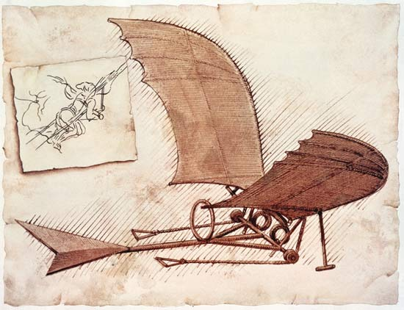  - does anybody know this picture?  - what does it represent?  - where did you see it?  Teacher shows the video summarising up the history of Leonardo’s inventions  https://youtu.be/9fj1OuAUv_8  asking students to pay attention to the quoted historical events, as they will represent the starting point of the guided discussion. | 10 min.
Initial Immersive Experience | “And now let’s go inside the atmosphere of Leonardo’s inventions”  https://youtu.be/HwcXKPvSgdc  Learners put on the VR headsets and explore the video with the support of the teacher. This experience offers students the opportunity to concretely live the atmosphere, the sounds, and the emotions of the Museum, feeling part of the historical events they are studying. | 20 min.
Guided Immersive Experience | Teacher asks students to watch again the video Once again, teacher asks students to pay attention to the main didactical resources mentioned in the video, as they will be part of the formative assessment. | 5 min.
Follow up | 1) History of sciences and technology by images  The history of humanity is certainly linked to the progress of science and technology. These images suggest a short path of research and stimulus to understand some fundamental stages of scientific and technological progress.  Image 1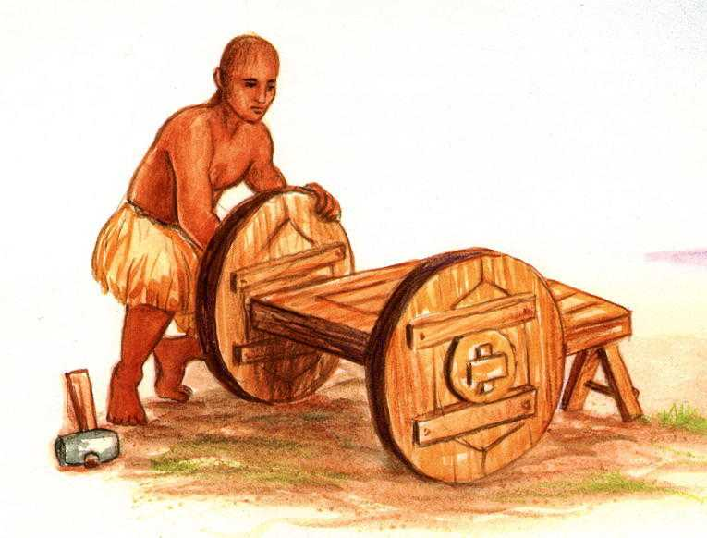  Image 2 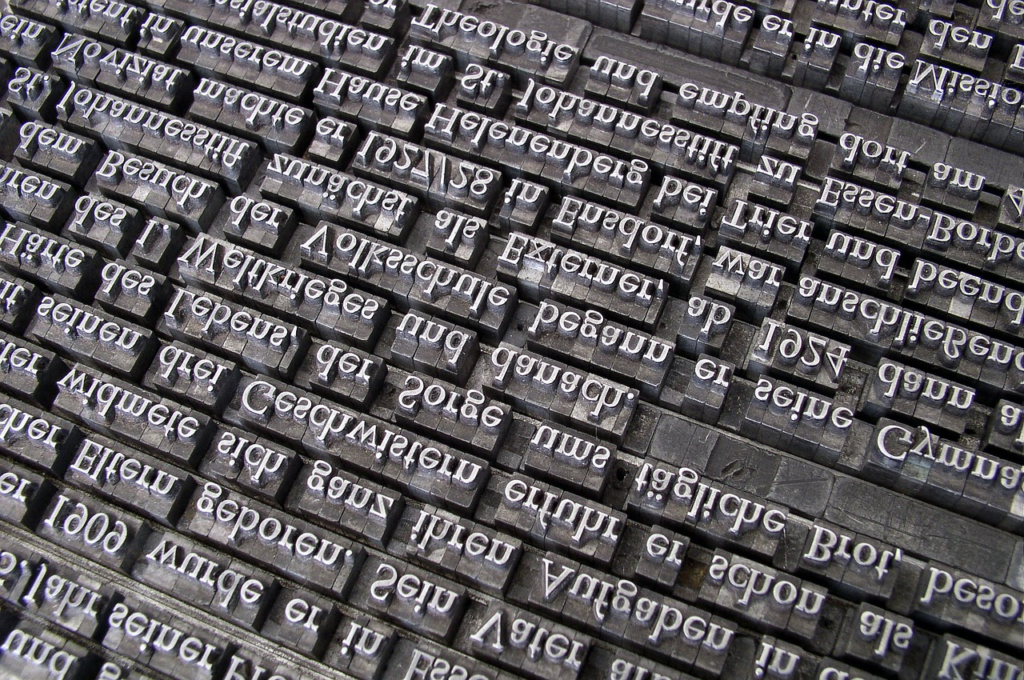  Image 3  Image 4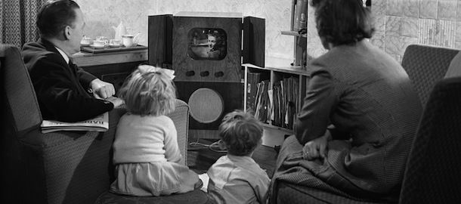  2) Group work  Students, divided into groups, are asked to identify further historical / iconic images officially belonging to the development of techonologies. Then, one representative for each group is asked to presents the results achieved during the group work.  3) Universal symbols  “The Vitruvian Man is the most recognized symbol of Leonardo’s activities as inventor and scientist. Do you know any other symbol / logo which work as a universal symbol, which does not need any lettering of the product’ name it represents?” | 10 min.  10 min.  5 min.
Formative Assessment | - “How many inventions were mentioned in the videos?”  - “What is the location of the Museum showed in the video??”  - “Which invention do you like more between those showed in the video??”

